AudioWOMAN Program - USER GUIDE

## Overview

**AudioWOMAN is a tool designed for efficient file path generation, modification, and renaming. By combining multiple columns of text data, it ensures consistency while allowing flexibility in column inputs—making it ideal for batch processing and file organization.**

**The program includes tools to modify paths through truncation or text replacement before applying changes to actual files.**

**It also features an automated renaming system that organizes files into structured directories based on the generated paths, and 2 tools for analyzing data: file audit and media info.**

## Getting Started

### Launching the Program

**🔹 Windows Users: Run the .exe file.  
🔹 Mac Users: Run the .dmg file.**

## How to Use

# 1. Generate New Paths / Add More Paths

**📌 What it does:  
Creates file paths by concatenating values entered in each column.**

**📌 Steps:**

1. **Add up to 12 columns to put your text and remove them as needed**
2. **Enter text into the textboxes for each column. Each line represents a separate entry.**

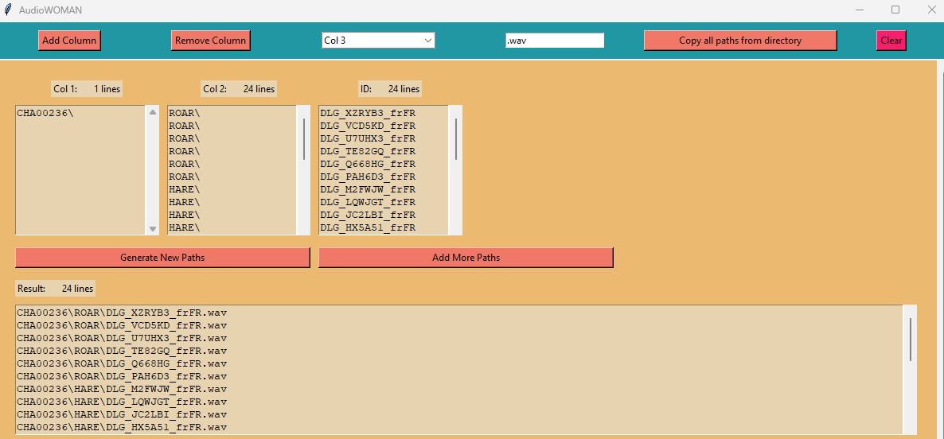

1. **Ensure the ID column contains the reference row count.**

**Other columns should either:**

* + **Match the ID column in the number of entries, or**
  + **Contain a single value (automatically expanded).**

1. ***(Optional)* Add a file extension (e.g., .wav, .csv).**



1. ***(Optional)* Copy in the first column all file paths from a directory, including the ones in subdirectories.**



1. **Use the "ID Column" dropdown to select the reference column.**

##### **📌 To generate your list of path you can choose one of these two options:**

**- Click "Generate New Paths" to create concatenated paths. The results will appear in the Result area and will overwrite whatever was already in the result area.**

**- Click "Add More Paths" to add concatenated paths below the one that are already in the Result area.**

**Results**

**✔ Generated or modified paths appear in the Result area.**

**✔ Example output for three columns (Col 1, Col 2, Col 3) with a .txt extension:**

**value1_part1_value2.txt**

**value1_part2_value2.txt**

**value1_part3_value2.txt**

# 2. Truncate Paths

**📌 What it does:  
Removes part of a file path from either the left or right based on your selection.**

**📌 Steps:**

1. **Use your generated paths or manually enter text (copy/paste) into the "Result" textbox.**
2. **Choose whether to truncate based on:**
   * **A specific number of characters**
   * **A specific character (e.g., /, -)**
3. **Select "Left" (keep the right part) or "Right" (keep the left part).**
4. **Click "Apply Truncation".**

**⚠ Important: The program searches for the first occurrence of the specified character. If the character isn’t found in all paths, an error will be displayed.**

# 3. Replace Text in Paths

**📌 What it does:  
Finds and replaces specific text within file paths.**

**📌 Steps:**

1. **Enter the text you want to replace.**
2. **Enter the new text (or nothing if you want to erase the text you entered).**
3. **Click "Apply Replace".**

**💡 Tip: Use this to cut parts of your path (e.g. replace “/001/” by nothing).**

**⚠ Important:**

**For the “Replace All” option, the program searches for the first occurrence of the text you entered. If the text isn’t found in all paths, an error will be displayed.**

**For the “Partial Replace” option, every occurrence of the text present in any path will be replaced.**

# 4. Renaming Files

**📌 What it does:  
Copies all files from a selected folder into a new _renamed folder and renames them based on the generated paths. The program also creates necessary subdirectories.**

**📌 Steps:**

1. **Select the source folder where your files are stored.**
2. **Click "Rename".**
3. **Files will be copied into a “_renamed folder”, preserving subfolder structure.**

**⚠ Important: Ensure the number of copied files matches the number of generated paths to avoid errors.**

# 5. File Audit

**📌 What it does: Compares filenames from the generated paths with actual files in a selected folder, identifying missing and extra files.**

**📌 Steps:**

1. **Put the list of filenames in result textbox (copy/paste it, or generate it)**

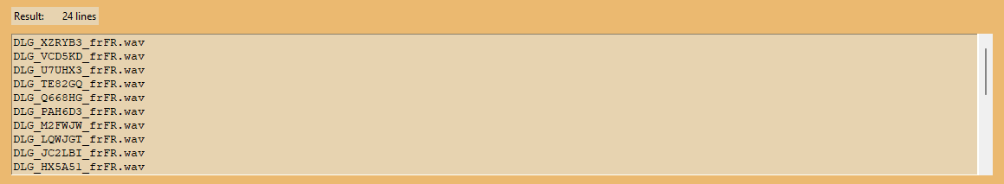

**⚠ Important: Ensure the list of filenames contains the exact name of the files with the extension (e.g. “name_of_the_audio_file.wav”)**

1. **Select a folder to analyze.**
2. **Click on button "File Audit".**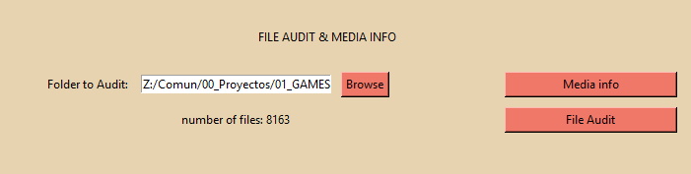
3. **The program will compare the generated paths with actual filenames and display missing and extra files.**

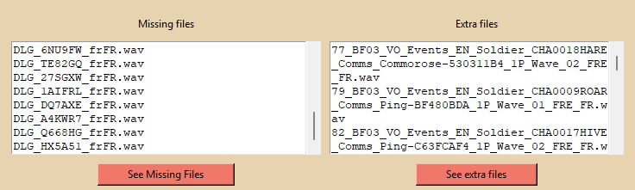

**You can export the results as a text files.**

# 6. Media Info

**📌 What it does: Checks all audio files in a selected directory for uniformity in sampling rate, bit depth, and number of channels.**

**📌 Steps:**

1. **Select a folder containing audio files.**
2. **Click on button "Media Info".**
3. **The program will check if all files have the same parameters.**

**If discrepancies are found, a detailed report will be displayed and can be saved.**

# 7. Clear All: Reset Everything



**📌 What it does:  
Resets all text fields, selections, and settings, clearing any loaded paths.**

**💡 Use this when: You want to start over with a clean slate.**

**This tool makes file organization and batch renaming seamless and efficient. Now do your magic! 🚀**